1. 撰寫一程式，宣告三個整數a,b,c，令a=2, b=3, c=ab，並印出以下訊息

(檔案命名: HWK1_XXXX_01.cpp, XXXX為你的學號末四碼)

"The value of a is 2. The value of b is 3."

c=ab=6 \\ c is the largest number

1. 課本Chapter 2 Problems第32題, Write a statement to print the following line. Assume the total value is contained in a variable named cost. …..

(檔案命名: HWK1_XXXX_02.cpp, XXXX為你的學號末四碼, 其餘類推)

1. 課本Chapter 2 Projects第39題, Write a program using printf statements to print the three first letter of your first name in big block. …….
2. 撰寫一程式印出以下表格，x是整數，y,z是單精密度實數，x,y,z的關係如下

y = 2.5 x3 -22.5 x+2.5

z = -y2 + 12.8 y

表格中各欄位寬度分別為x:6個字元, y:10個字元, z:10個字元

<程式輸出>

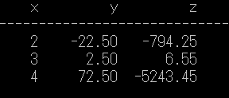

<提示>

printf("%5.3f",z) ; // z的欄位寬度5, 小數點3位